**EduLibya Co-founders bios and pics**

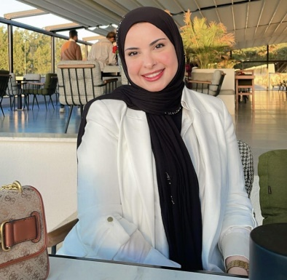Sara Alrefadi is a certified English as a second language teacher with CELTA and a Graduate Teaching Assistant in the Department of Literature at the Faculty of Languages, University of Benghazi. Currently, she is pursuing her Master's degree in Applied Linguistics, further expanding her expertise in this field. Her research interests include the role played by education in post-conflict communities, sustainable developments, social cohesion, peace building and societal growth. Alongside her academic and teaching pursuits, Sara is a passionate humanitarian, working and volunteering with various non-governmental organizations (NGOs).

Sarah Sweneya is a former teacher who currently practices as Speech-Language Pathologist in Canada. She has experience working with toddlers and older adults in a variety of settings: schools, clinics, and hospitals. Her practice emphasizes the importance of enhancing communication to promote the overall wellbeing of her clients. As a Speech-Language Pathologist, Sarah supports families and teachers in developing individualized treatment plans, offering strategies and resources, and advocating for children's needs.

Munira Bengashier has a PhD in Micro Nano Electronics and an MPhil in Micro-nano Electronics from the University of Malta, an MSc in Electronic Engineering and a BSc in Computer Engineering from University of Tripoli-Libya. Her research interests and skills include RF-MEMS Resonators and Switches, Design- Simulation and Characterization. Munira is a Certified Instructor in ICS/ICDL since 2008.

Malak Ben Giaber is systemic practitioner and trainer working with the Solution Focused Approach. She has an MSc in Clinical Psychology and a BA in Psychology. She has worked with communities across the South West Asia and North Africa region with humanitarian NGO’s consulting on issues pertaining to Mental Health (MH) and Psychosocial Support (MHPSS). She is a Director of Ejaz for Consultancy and Training, a centre in Tripoli, Libya where she works with individuals, families, professionals and groups to find ways forward in challenging contexts. She was previously and is currently assigned president of a consultative committee ensuring that work relevant to MH in Libya meets international guidelines and standards of best practice, ethical care and competency. Malak is also a qualitative researcher in the nature of civil participation and processes involved with change on the individual and community level. She is currently involved with drafting a MH policy for a Libyan civil society organization.

Reem Ben Giaber is a PhD candidate at IOE’s Department of Learning and Leadership at UCL’s Faculty of Education and Society in the UK. She has an MA in Education Studies from Concordia University. Reem is an Associate Fellow at the Higher Education Academy and a co-founder of a research and practice network: SWANA Forum for Social Justice. Reem has worked in the education sector for 20 years in Libya, Canada and the UK. She was Guest Lecturer at the IOE and is an experienced Seminar Leader in the IOE’s Education, Practice and Society Department. Reem’s research interests include John Dewey’s pragmatist philosophy of education, teacher agency, teacher education and professional development, civil society and civil society organisation and the role teachers may play in the link between school and society in Libya.